**EMPLOYEE INFORMATION ENTRY FORM (TO BE FILLED IN CAPITAL LETTERS ONLY)**

**EMPLOYEE NO:**

**DATE OF JOINING (DD-MMM-YYYY): 15 – 02 – 2021**

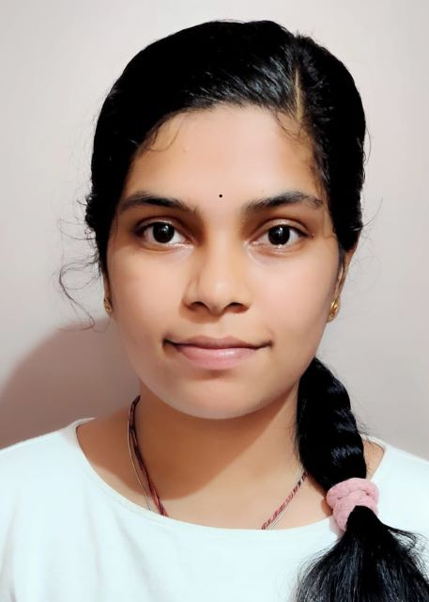

|  |
| --- |
| **GENERAL DETAILS** |
| **Details To be filled as per passport** |
| **First / Given Name: Samhitha** |
| **Last / Surname: Rudresh** |
| **Date of Birth (DD-MMM-YYYY): 19 – 10 – 1999** |
| **Age: 21** |
| **Father’s Name: Rudresh Hucheerappa** |
| **Mother Maiden Name: Hemamalini Bengaluru Sadashiva** |

|  |  |
| --- | --- |
| **PERSONAL DETAILS** | |
| **Marital Status: Single Married** | **Spouse Name (if Married):** |
| **PAN:** | **Nationality: Indian** |
| **UAN (PF No) :** | **Gender: Male Female** |
| **Aadhaar Card No : 8997 8992 6414** | **Blood Group: B+** |

|  |  |
| --- | --- |
| **PASSPORT DETAILS** | |
| **Passport Number: Z5160006** | **ECNR Status:** Yes No |
| **Date of Issue: 28/ 08/ 2018** |
| **Date of Expiry: 27/ 08/ 2028** |

|  |  |  |  |  |  |  |
| --- | --- | --- | --- | --- | --- | --- |
| **EDUCATION DETAILS** | | | | | | |
| **Level** | **Institution Name** | **University / Board Name** | **Course** | **Specialization** | **Mode of Education** | **Year of passing** |
| **10th** | VVS Sardar Patel High School | Karnataka Secondary Education Examination Board | - | - |  | 2015 |
| **12th** | VVS Sardar Patel PU College | Department of Pre-University Education, Government of Karnataka | - | - | - | 2017 |
| **UG** | M S Ramaiah University of Applied Sciences | M S Ramaiah University of Applied Sciences | BTech | Computer science and Engineering | - | 2021 |
| **PG** | - | - | - | - | - | - |

**Gap in Education:** Yes (more than 2 years) No

**If yes, please specify: _________________________________________________________________________________**

**___________________________________________________________________________________________________**

|  |  |  |  |  |  |  |
| --- | --- | --- | --- | --- | --- | --- |
| **PROFESSIONAL DETAILS (Last 3 Organizations)** | | | | | | |
| **Name of the Organization** | **Date of Joining** | **Date of Relieving** | **Designation** | **Total No.of Years** | **Last Drawn CTC (pa)** | **Domain Experience** |
|  |  |  |  |  |  | Yes No |
|  |  |  |  |  |  | Yes No |
|  |  |  |  |  |  | Yes No |

**Gap in Professional Experience:** Yes (more than 1 Year) No

**If yes, please specify: _________________________________________________________________________________**

**___________________________________________________________________________________________________**

|  |  |
| --- | --- |
| **CONTACT DETAILS** | |
| **Mobile No: 9480038212** | **Alternate No: None** |
| **Residence No: None** | **Email id: samhitharsam@gmail.com** |
| **Permanent Address:**  **#62/1, “SHIVA”, 2nd Cross, Srirampuram, Bangalore - 560021** | **Current Address: Same as Permanent Address**  **#62/1, “SHIVA”, 2nd Cross, Srirampuram, Bangalore - 560021** |

|  |  |
| --- | --- |
| **EMERGENCY CONTACT DETAILS** | |
| **Emergency Contact 1** | **Emergency Contact 2** |
| **Name: Rudresh H** | **Name: Hemamalini B S** |
| **Relationship: Father** | **Relationship: Mother** |
| **Mobile No: 9738319227** | **Mobile No: 9482228427** |
| **Residence No: None** | **Residence No: None** |
| **Address:**  **#62/1, “SHIVA”, 2nd Cross, Srirampuram, Bangalore - 560021** | **Address : Same as Emergency Contact 1 Address**  **#62/1, “SHIVA”, 2nd Cross, Srirampuram, Bangalore - 560021** |

**DECLARATION:** I hereby declare that the above furnished information is true and best to my knowledge.

**DATE: 15/FEB/2021 SIGNATURE:** 